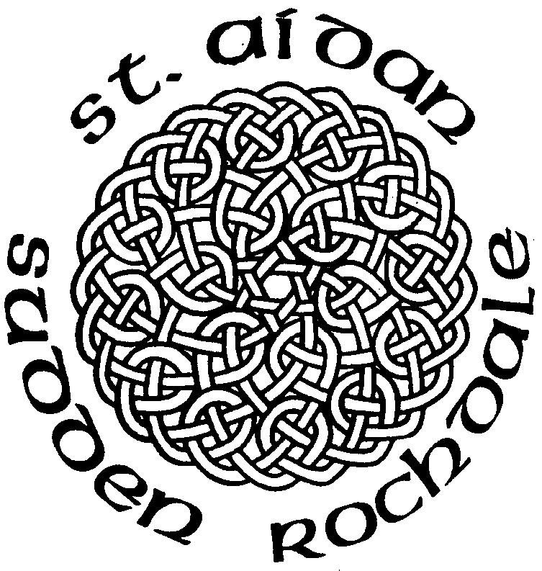

Weekly Services
Sundays:
10am - Family Communion
Wednesdays:
9.30am - Holy Communion

Weddings and Baptisms
by appointment

Anthems

Rejoice in the Lord
Always - Redford

Gospel Reading

Luke 3 ; 7 - 18

16th Dec 2012
Advent 3
The Childrens
Christmas
Service

St. Aidans Church
Sudden, Rochdale

Contact Us

Vicar
Rev Michael Read
41 Harold Lees Road
Heywood, OL10 4DW
Tel: 01706 360693 vicar@staidan.org.uk

Churchwardens:
Malcolm Bywater
168 Bury New Road,
Heywood
Tel: 01706 623546
malcolm@staidan.org.uk

John Tolley
11 Binns Nook Rd., Syke
Tel: 01706 527973
john@staidan.org.uk

Verger & Deputy Churchwarden
Ronnie Ogden
22 Ashley Close
Tel: 01706 630651

Hall Bookings
Andrew Huxley
4 Birchfield Drive
01706 658206
andrew@staidan.org.uk

PCC Secretary
Ann Montgomery
5 Briar Close, Norden
Tel: 01706 359869
ann@staidan.org.uk

Treasurer:
Debra Buckley
14 Broadhalgh Road,
Tel: 01706 647703
debra@staidan.org.uk

Events Diary
December
Sun | 16th | 10.00am | St Aidan’s Childrens Christmas Service
Sun | 16th | 6.30pm | Masonic Carol Service
Thurs | 20th | 7.30pm | Magistrates Carol Service
Sun | 23rd | 6.30pm | St Aidan’s Carol Service
Mon | 24th | 2.30pm | Crib & Christingle Service at All Souls’
Mon | 24th | 11.30pm | St Aidan’s Christmas Eucharist
Tues | 25th | 10.00am | Parish Family Eucharist with Carols at St Aidan’s
Tues | 25th | 10.00am | Parish Family Eucharist with Carols at All Souls’

Regular Events

Open Church – 1st, 3rd & 5th Wednesdays 10am-4pm
St Aidan’s Art Group – Mondays 12.45pm
Choir Practice – Thursdays 7pm/7.45pm
FairTrade Stall – last Sunday of the month
St. Aidan’s Men’s Group – 1st Weds of the month
St. Aidan’s Ladies Guild – monthly meetings
St Aidan’s Flower Group – Fridays 7.30pm
Knitwits – Fridays 2pm
Councillor’s Surgery – 1st Saturday 10.15am
Coffee Morning at All Souls – 2nd Sat. 10.30am
Messy Church at All Souls – last Sat. 10-11.30am

The Meaning of ADVENT
Advent is the season including the four Sundays preceding Christmas, Which is observed in many Western Christian churches as a time of expectant waiting and preparation for the celebration of the Nativity of Jesus at Christmas. The term is an anglicized version of the Latin word adventus, meaning "coming."

The Meaning of The Advent Wreath
3rd CANDLE – (pink) THE SHEPHERD CANDLE or THE CANDLE OF JOY – The angels sang a message of JOY! “…and she gave birth to her firstborn, a son. She wrapped him in cloths and placed him in a manger, because there was no room for them in the inn. And there were shepherds living out in the fields nearby, keeping watch over their flocks at night. An angel of the Lord appeared to them, and the glory of the Lord shone around them, and they were terrified. But the angel said to them, ‘Do not be afraid. I bring you good news of great joy that will be for all the people. Today in the town of David a Savior has been born to you; he is Christ the Lord. This will be a sign to you: You will find a baby wrapped in cloths and lying in a manger.’ Suddenly a great company of the heavenly host appeared with the angel, praising God and saying, ‘Glory to God in the highest, and on earth peace to men on whom his favor rests.’ When the angels had left them and gone into heaven, the shepherds said to one another, ‘Let’s go to Bethlehem and see this thing that has happened, which the Lord has told us about.” (Luke 2:7-15)

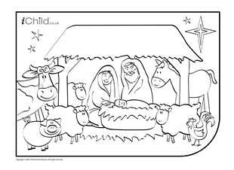

This morning we mark our Patronal Festival as this is the Sunday nearest to St Luke’s Day (18th Oct).
On St Luke’s Day 1913, the Foundation Stone was laid by Lady Rochdale and we will be celebrating the centenary of this event next year.
St. Aidan’s C of E Parish Church
Manchester Rd Rochdale OL11 2EL
Vehicular Access OL11 3NH
www.staidan.org.uk


Refreshments are served in the Hall after the Service.

JUNIOR CHURCH: our Children’s Groups meet in the Hall
during the Morning Service: Kindergarten (3-6);
Adventurers & Explorers (7 –14)

GIFT AID LEGISLATION
If you are a taxpayer and don’t at present make use of the weekly envelope scheme, kindly use the Gift Aid Envelopes you will find near your seat. We will then be able to claim 25p for every £1 you give. Please remember to fill in your name and address.

INTERCESSIONS
Please add names for the Intercessions in the book at the back of Church.

Welcome to St Aidan’s Church
We are a friendly caring church.
If we can help you in any way, please speak to the Vicar, Sidespersons or any of the Church Officers.

DUTIES NEXT WEEK: 23rd Dec Advent 4

Sidespersons | A & J Clarke, L Hutton, J Hornby
Coffee rota | D Thorneycroft, S Squires, D Pickup
Hall preparation | B Hassall, A Clarke
Junior Church | Deborah, & Rachel,Tracey & Andrew | Julie B & Ros
Open Church | Please check rota
Church Cleaning

Please email notices to newsletter@staidan.org.uk by noon on Weds and if you wish this notice sheet to be emailed to you every week, please contact newsletter@staidan.org.uk
Please send items for the website to webmaster@staidan.org.uk

MASONIC CAROL SERVICE TONIGHT AT 6.30PM

The Freemasons of Rochdale extend a warm welcome to everyone to join them at their annual Carol Service this evening at 6.30 pm. The Church Choir will lead the Service and Freda Farnworth will be singing a solo. Following the Service Tea/ Coffee and Mince pies will be served in the Church Hall

THE WALKING GROUP
Start 2013 by joining our walking group, The first walk will be on Sat 5th Jan starting at The White House in Littleborough we will do a circular walk of 5 & half miles over Blackstone Edge & viewing reservoirs.
Meet as usual in the Church car park at 8.45am, new walkers always welcome, For further info contact Lynne and Bill 01706 522559

CHRISTMAS TREE
Optional Way To Send Your Christmas Greetings
There will be a Christmas Card Tree at the back of Church from Advent Sun 2nd Dec. If you wish you can place one card on the tree to greet all your friends at St Aidan’s. Perhaps with the money saved from buying one card instead of many, you may wish to make a donation to either a charity of your own choice or gift aid to St Aidan’s

THE CHILDREN’S NATIVITY PLAY

Today at the end of the service the children will perform a short nativity play. We would like you join in please. We like audience participation here at St Aidan's! Nothing too difficult - please just join in with the carols. You'll know when as a short introduction will be played. The words are in the separate handout you should have received. We hope you enjoy it.

REBEKAH’S FUND RAISING
FESTIVE CHEER
Please come & join Debra and Jonathan Buckley for mulled wine & mince pies & nibbles etc at 14 Broadhalgh Rd Bamford on Sun 23 rd Dec from 8.00pm(after the 6.30 pm service of Nine Lessons and Carols) Tickets £5 available from Debra ( limited No )

